**Assessing the evolutionary response of oyster larvae to multiple anthropogenic stressors: a mechanistic approach**

­­­­­­­­­­­­­­

**Overview**

Coastal species are often exposed to multiple natural and anthropogenic stressors simultaneously in their natural habitat. There is potential for these stressors to interact and have an additive or synergistic negative effect on the organisms. Coastal marine invertebrates, such as the eastern oyster *Crassostrea virginica* are highly vulnerable to changes in their environment, especially in the early life stages when they are still developing crucial physiologicalcontrols for overcoming exposure to stressors (Gobler and Talmage 2014). Within coastal zones, the excessive delivery of nutrients from agriculture and urban centers stimulates algal productivity, and the subsequent microbial degradation of this organic matter reduces oxygen levels, creating hypoxic conditions. This microbial respiration, as a result of nutrient excess, also contributes to localized acidification, termed coastal acidification (CA). Through the process of respiration, levels of CO2 and O2 are stoichiometrically connected in coastal ecosystems, as they can be altered by differences in gas exchange and chemical equilibria. Recent studies have shown a close correspondence between low dissolved oxygen (LDO) and CA systems (Feely et al. 2010; Paulmier et al. 2011; Waldbusser et al. 2011), with *p*CO2 levels in LDO zones often of a magnitude greater than predicted for surface oceans at the end of this century (>1,000 µatm) (Melzner et al. 2012).

**While the physiological effects of CA and LDO have been well characterized separately, there are few studies that have examined them simultaneously**, especially in the sensitive larval stages of marine organisms (Gobler et al. 2014). Additionally, **very few studies focus on the underlying mechanisms driving these physiological responses and possibly leading to resistance (i.e. identifying genes) to multiple stressors.**

**Intellectual Merit**

The proposed study will be is one of few to test the concurrent effects of CA and LDO,and will serve as an example to others that multi-stressor experiments are essential for understanding how intertidal ecosystems will truly adapt to long-term climate change and human population growth. Additionally, this research will advance our understanding of the underlying mechanisms driving these physiological responses by connecting genomic genotypes to phenotypic performance in the larval stage.

**Broader Impacts**

All methods and bioinformatic analyses used in this study will be accessible to the public with open source programs. This research will involve three undergraduate students, who will be recruited following the RI NSF EPSCoR personalized recruitment process. Results from this study will help inform efforts by fisheries managers, oyster reef restoration organizations, and shellfish hatcheries (both for aquaculture and restoration practices) across most of the Atlantic coast of the US. Additionally, this research will help enhance marine aquaculture practices, by providing oyster hatchery facilities with information about the genes and traits involved in adapting to long-term ecosystem change and information on selection and screening of broodstock for robust larvae. All members of the research team will work in collaboration with Save the Bay in Narragansett, assisting with their educational outreach activities within the

Coastal and Classroom Programs.

Over 50% of the population of the United States of America and over 60% of the population of the world live in coastal areas (NOAA 2011). Technological advances and the increased demand for resources linked to growing human populations have led to massive alteration and exploitation of coastal water ecosystems (USCOP 2004), particularly in areas with higher human population densities (Halpern et al. 2008). Despite an overwhelming recognition and focus on multiple stressors across the fields of marine science in recent years, the cumulative impact of multiple anthropogenic stressors still remains relatively unknown (Crain et al. 2008; Griffen et al. 2016). The realization of the full magnitude of atmospheric CO2 driven global climate change has only reinforced interest in multiple stressors because of the coupling of major vectors of ocean change, such as rising sea surface temperatures and ocean acidification (Boyd and Hutchins 2012; Strong et al. 2014).

1. Background:

Deoxygenation of ocean waters has been one of the most drastic and prominent changes in marine ecosystems over the last 50 years (Diaz and Rosenberg 2008; Zhang et al. 2010; Breitburg et al. 2015). Coastal hypoxia (dissolved oxygen (DO) levels less than 2 mg/L), and hypoxic events have increased dramatically over the last 60 years (Zhang et al. 2010; Breitburg et al. 2015), mainly because of increases in human derived discharges of nutrients and organic matter (Diaz and Rosenberg 2008). DO in coastal waters is regulated by the balance between oxygen production (via photosynthesis), respiration, and surface exchange with the atmosphere (Zhang et al. 2010).

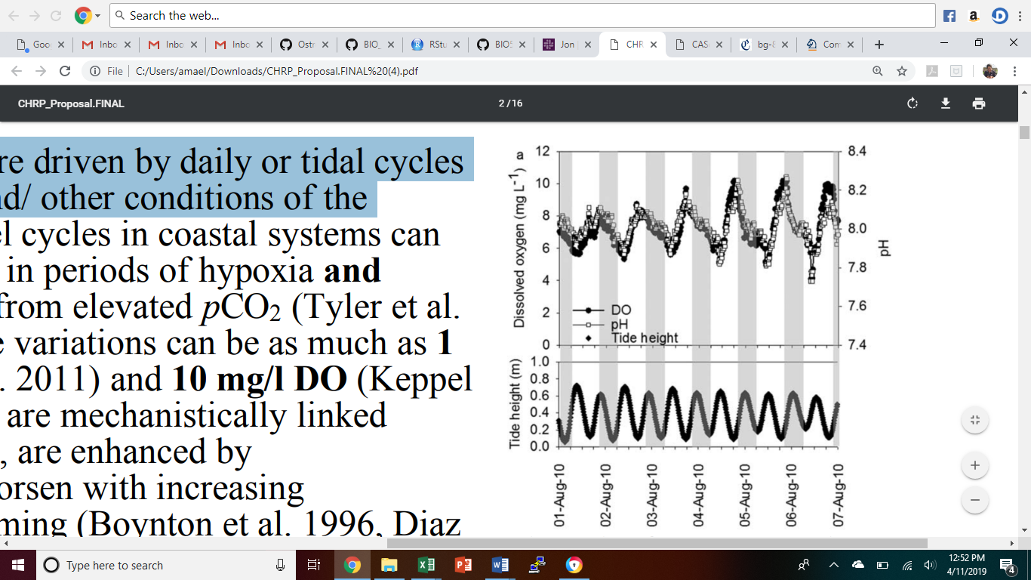For coastal and estuarine systems, atmospheric CO2 plays a minor role in regulating overall pH dynamics (Borgesa and Gypensb 2010), with the main source of CO2 in coastal systems coming from microbial and macrofaunal respiration. Nutrient inputs from rivers and atmospheric deposition drive primary production which in turn causes respiration and contributes to localized acidification. The tight coupling between nutrient inputs and primary production makes the carbonate chemistry of coastal waters sensitive to human activity. The anthropogenic acidification of coastal waters, or “coastal acidification” (CA) is driven largely by eutrophication, or excess nutrient loading.

LDO and CA are stoichiometrically connected in coastal ecosystems (Pörtner 2008), with similar naturally occurring diel cycles that are driven by daily or tidal cycles of respiration, photosynthesis, and/or other environmental conditions (Figure 1). These two stressors are enhanced by eutrophication, and will likely worsen with increasing atmospheric CO2 and global warming (Diaz and Rosenberg 2008).

Recent and past reviews of the interactions and impacts of multiple stressors have not identified common patterns or unifying concepts across studies. It is suggested that this failure is due to most studies investigating multiples stressors only focusing on “phenomenological” effects of multiple stressors (such as mortality or growth) without investigating the underlying mechanisms for these responses (Griffen et al. 2016). Griffen et al. argue that a proper framework for understanding multiple stressors in marine systems should involve:

**Figure 1: Coupling of DO and pH.** Diel cycling DO and pH in the Honga River, MD. Adapted from Burrell et al. 2015.

1. Investigation of the mechanistic impacts of multiple stressors on the individual level
2. Scaling of individual responses to the population level
3. Understanding the context of population-level response across communities and ecosystems

The proposed research will study two prevalent anthropogenic stressors on marine populations: hypoxia (LDO) and coastal ocean acidification (CA). The proposed research will follow this framework by identifying the genes and genotypes in the eastern oyster involved in the response to combinations of these two stressors across life history stages.

Oysters are an important species in coastal zones due to their economic value and the vast range of ecosystem services they provide, including robust water filtration and the creation of reefs that act as benthic habitat to other coastal species (Newell, 2004). Additionally, the eastern oyster plays a large part in supporting the fishing and aquaculture industry (Gómez-Chiarri et al. 2015b). Despite the economic and ecological importance of oysters, there has been a dramatic decline in biomass over time (Zu Ermgassen et al. 2012), leading to harvest levels of wild oysters that are significantly below historic values (NOAA 2017). Large efforts are in effect to restore oyster populations in US estuaries, and the long-term success will depend on successful larval recruitment to restored reefs.

1. Specific Aims:

**Aim 1:** *Use short-term exposures on larvae of the eastern oyster* *Crassostrea virginica to determine the effects of LDO and CA on larval growth, shell morphology, respiration, and mortality.* The environmental stressors LDO and CA have different effects on marine organisms when they occur separately. However, when these stressors co-occur there is the potential for them to interact and have and additive or synergistic negative effect on the organisms. This could result in greater negative physiological responses than what was previously expected.

**Aim 2:** *In those same exposures, use state-of-the-art genomic tools to determine which genes are involved in the physiological response to exposure.* Sequencing RNA directly from larval pools can be used to compare expression levels across treatments. Differentially expressed genes to LDO and CA may indicate which genes are critical to survival. Genes that are differentially expressed in LDO, CA, and LDO/CA treatments relative to the control treatment will be used as target genes in Aim 3.

**Aim 3:** *Identify specific genotypes that offer higher larval survival to exposure.* Once the genes in Aim 2 are identified, the genomes of each larval pool can be sequenced using sequence capture probes. Differential survival of genotypes can be measured by detecting changes in allele frequencies across pools. Identifying genotypes that offer higher survival to LDO and CA exposure can be used to screen oysters for restoration efforts.

1. Research Approach:

*pCO2 x DO System Design:* The Luther Blount Aquaculture Research Lab at the University of Rhode Island’s Bay Campus has the space and resources needed to house multiple mesocosms. To determine the combined effects of CA and LDO on larval oyster stages, this study will cross *p*CO2 at 2 treatment levels with dissolved oxygen (DO) at 2 treatment levels. The 2 *p*CO2 levels will include an ambient level (*p*CO2=~450 µatm) and elevated level (*p*CO2=~2,000 µatm) that is predicted to occur at the end of this century (Gobler and Talmage 2014). Each *p*CO2 treatment will be crossed with ambient DO conditions (~8 mg l-1) and low DO conditions (~2.0 mg l-1) (Gobler et al. 2014). These 4 treatment conditions will be randomly assigned across 12 mesocosms (three replicates per level) (Figure 2). The ambient *p*CO2 and ambient DO cross will serve as the control in the experiment. Larval oysters will be mass-spawned from crosses of five males and five females. 12 hours post fertilization, larvae will be counted and transferred into each mesocosm. Carbonate chemistry will be controlled with a pH-stat system and DO will be controlled with a DO controller (Hach® sc200 Controller). The exposure will be repeated 3 times per year for two years with new broodstock for each replicate.

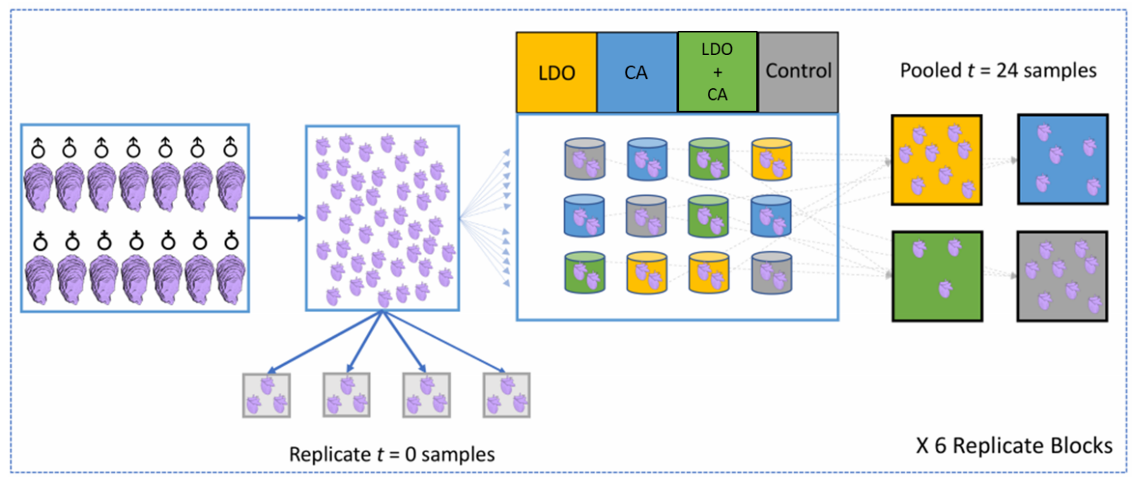

**Figure 2: pCO2 x DO Experimental Design.** Five males and five female oysters will be used for broodstock for each spawn. Larvae will be pooled and grown for 15 hours prior to exposure. After 15 hours, four replicate samples of at least 20,000 larvae will be taken as T0 time points. Remaining larvae will be split into four different treatments, (LDO, CA, LDO/CA, and Control) with three replicate mesocosms within each treatment. Adapted from Puritz 2018.

*Physiological response:* At one, four, seven, and fourteen days post exposure, larval mortality, shell morphology, growth, and respiration will be assessed. Mortality will be determined by counting the number of living larvae in a sub-sample from each rearing container. All dead larvae will be removed from the mesocosm. Respiration will be measured using short-term incubation experiments and quantifying changes in oxygen. To determine growth rates and characterize shell morphology, a subset of individuals will be preserved and then measured with microscopy. All response variables will be analyzed using general or generalized models with treatment as a fixed effect and time as a random effect to account for repeated measures.

*Genomic Analysis:* During the exposures, a sub-sample of larvae will be taken for genomic analysis just prior to transferring them into the mesocosms, and then again at one, four, seven, and fourteen days post transfer. At the end of the experiment, all remaining larvae will be preserved for genomic analysis. This study will take advantage of sequence capture probes which allow for the direct capture of genomic sequences that correspond to expressed genes (Puritz and Lotterhos 2018). Bioinformatic analysis will allow for the characterization of the genes that are relevant to CA and LDO exposure as well as the examination of allele frequencies at target loci in larval populations after exposure. Loci under selection from CA and LDO exposure will show similar changes in allele frequencies across replicates. Examining changes in allele frequencies will help identify genotypes that offer higher survival to combined CA and LDO.

1. Intellectual Merit:

As human populations continue to rise in coastal areas, eutrophication and associated coastal acidification are rapidly intensifying. Current research has focused heavily on responses to *p*CO2 alone, but it is criticalthat we understand organismal responses to a multitude of concurrent stressors, which is a closer proxy to natural environments. There is potential for stressors to interact in an additive or synergistic way, making their effect on organisms greater than what was previously characterized. This study is **one of few to test the concurrent effects of CA and LDO**,and will serve as an example to others that multi-stressor experiments are essential for understanding how intertidal ecosystems will truly adapt to long-term climate change and human population growth. Additionally, this research will **advance our understanding of the underlying mechanisms** driving these physiological responses by connecting genomic genotypes to phenotypic performance in the larval stage.

1. Broader Impacts:

*Accessibility of results:* All methods will be accessible to the public with open source programs. This includes all bioinformatic analyses, which will be fully documented, including **all** code, configuration files, and additional data. Additionally, all results will be published in open-access format. The public will also have access to live-stream videos, showing the set-up and maintenance of the pCO2 x DO system, in addition to spawning and implementation of the exposure experiments.

*Training:* Training during the grant period will be provided for up to three undergraduates, who will be trained in all aspects of the project. Recruitment will employ the RI NSF EPSCoR personalized recruitment process, which will increase participation of students from underrepresented groups and ensure that they are working within the existing support structure that was created to retain minority students in STEM.

*Outreach:* Understanding the physiological limits of larvae and the mechanisms behind synergistic effects of multiple stressors will help **inform efforts by fisheries managers, oyster reef restoration organizations, and shellfish hatcheries** (both for aquaculture and restoration practices) across most of the Atlantic coast of the US. Results of this study will show that coastal managerial criteria may not adequately protect marine life in some ecosystems, as they are based strictly on oxygen levels but not *p*CO2. Therefore, future environmental regulations developed to protect estuarine organisms in regions prone to hypoxia should consider the concurrent effects of acidification on coastal organisms, especially as climate change accelerates the intensity of acidification in coastal zones. This research will also help **enhance marine aquaculture practices**, by providing oyster hatchery facilities with information about the genes and traits involved in adapting to long-term ecosystem change and information on selection and screening of broodstock for robust larvae. I plan to collaborate with Save the Bay, a non-profit organization whose goal is to protect and improve Narragansett Bay through education initiatives, policy reform, and restoration efforts. Results from this study can be used by their policy team to convince both state and local governments to pass laws that will further protect the Bay. Additionally, I can assist with Save the Bay’s educational outreach activities by getting involved in the Coastal and Classroom Programs. Outreach efforts will also be extended across the country by participating in programs such as Skype a Scientist.

**References Cited**

Borgesa, A. V. and N. Gypensb (2010). “Carbonate chemistry in the coastal zone responds

more strongly to eutrophication than ocean acidification.” Limnol. Oceanogr. **55**: 346–

353.

Boyd, P. W. and D. A. Hutchins (2012). Understanding the responses of ocean biota to a

complex matrix of cumulative anthropogenic change. Mar. Ecol. Prog. Ser. **470**: 125–

135.

Breitburg, D., Levin, L. A., Oschlies, A., Grégoire, M., Chavez, F. P., Conley, D. J., et al.

(2015). “Declining oxygen in the global ocean and coastal waters.” Science **359**(6371).

Burrell, R. B., Keppel, A. G., Clark, V. M., and D. L. Breitburg (2015). “An automated

monitoring and control system for flow-through co-cycling hypoxia and pH

experiments.” Limnology and Oceanography: Methods **14**(3): 168-185.

Crain, C. M., Kroeker, K. and B. S. Halpern (2008). “Interactive and cumulative effects of

multiple human stressors in marine systems.” Ecol. Lett. **11**: 1304–1315.

Diaz, R. J. and R. Rosenberg (2008). “Spreading dead zones and consequences for marine

ecosystems.” Science **321**(5891): 926-929.

Feely R. A., Aline S. R., Newton J., Sabine C. L., Warner M., et al. (2010). “The combined

effects of ocean acidification, mixing, and respiration on pH and carbonate saturation in

an urbanized estuary.”  Estuarine, Coastal, and Shelf Science **88**: 442-449.

# Gobler C. J., DePasquale E. L., Griffith A. W., and H. Baumann (2014). “Hypoxia and

# acidification have additive and synergistic negative effects on the growth, survival, and

# metamorphosis of early life stage bivalves.” PLoS One 9(1): e83648.

# Gobler, C. J. and S. C. Talmage (2014). “Physiological response and resilience of early life-

# stage Eastern oysters (*Crassostrea virginica*) to past, present and future ocean

# acidification.” Conservation Physiology 2(1).

# Gómez-Chiarri, M., Guo, X., Tanguy, A., He, Y. and D. Proestou (2015). “The use of -omic

# tools in the study of disease processes in marine bivalve mollusks.” Journal of

# Invertebrate Pathology 131: 137-154.

# Griffen, B. D., Belgrad, B. A., Cannizzo, Z. J., Knotts, E. R. and E. R. Hancock (2016).

# “Rethinking our approach to multiple stressor studies in marine environments.” Mar.

# Ecol. Prog. Ser. 543: 273–281.

Halpern, B. S. et al. (2008) “A global map of human impact on marine ecosystems.” Science

**319**: 948–52.

Melzner F., Thomsen J., Koeve W., Oschlies A., Gutowska M. A., et al. (2012). “Future ocean

acidification will be amplified by hypoxia in coastal habitats.” Marine Biology **160**(8):

1875-1888.

Newell, R. I. E. (2004). “Ecosystem influences of natural and cultivated populations of

suspension-feeding bivalve molluscs; a review.” Journal of Shellfish Research **23**(1):

51+.

NOAA, N. O. and A. A. NOAA’s State of the Coast (2011). THE U.S. POPULATION LIVING

IN COASTAL COUNTIES.

NOAA (2017). UNDERSTANDING SUSTAINABLE SEAFOOD. National Ocean Service

website, https://www.fisheries.noaa.gov/insight/understanding-sustainable-seafood

Paulmier A., Ruiz-Pino D., and V. Garcon (2011). “CO2 maximum in the oxygen minimum zone

(OMZ).” Biogeosciences **8**: 239-252.

Pörtner, H. (2008). “Ecosystem effects of ocean acidification in times of ocean warming: a

physiologist’s view.” Mar. Ecol. Prog. Ser. **373**: 203-217.

Puritz, J. B. (2018). “Assessing the evolutionary response of an ecosystem engineer to multiple

anthropogenic coastal stressors: a mechanistic approach.” (Research Proposal). Retrieved from the University of Rhode Island.

Puritz J. B. and K. E. Lotterhos (2018). “Expressed exome capture sequencing: A method for

cost-effective exome sequencing for all organisms.” Mol Ecol Resour**00**: 1-14.

Strong, A. L., Kroeker, K. J., Teneva, L. T., Mease, L. A. and R. P. Kelly (2014). “Ocean

acidification 2.0: Managing our changing coastal ocean chemistry.” Bioscience **64**: 581–

592.

US Commission on Ocean Policy (2004). An Ocean Blueprint for the 21st Century.

Waldbusser G. G., Voigt E. P., Bergschneider H., Green M. A., and R. I. E. Newell (2011).

“Biocalcification in the Eastern Oyster (*Crassostrea virginica*) in relation to long-term

trends in Chesapeake Bay pH.”  Estuaries and Coasts **34**: 221-231.

Zhang, W., Cao, Z., Peng, J., Chen, B. and S. Fu (2010). “The effects of dissolved oxygen level

on the metabolic interaction between digestion and locomotion in juvenile southern

catfish (*Silurus meridionalis* Chen).” Elsevier **157**(3): 212-219.

Zu Ermgassen, P. S. E., Spalding, M. D., Blake, B., Coen, L. D., Dumbauld, B., Geiger, S., et al.

(2012). “Historical ecology with real numbers: past and present extent and biomass of an

imperiled estuarine habitat.” Proc. R. Soc. B **279**: 3393-3400.